LITERATURE SURVEY REPORT
Title: Student Feedback Analysis Using Natural Language Processing (NLP) and Sentiment Analysis
1. Introduction
Student feedback is an essential component in evaluating teaching effectiveness and improving course quality. While quantitative feedback such as ratings is easy to analyze, qualitative feedback in the form of textual comments is often underutilized due to its unstructured nature.
This study focuses on applying Natural Language Processing (NLP) and Sentiment Analysis to automatically analyze student feedback. The aim is to extract meaningful insights from textual data and correlate them with numerical ratings to provide a more comprehensive evaluation of courses and instructors.

2. Problem Statement
The major problem addressed in this paper is:
- Difficulty in analyzing large volumes of unstructured student feedback manually
- Underutilization of qualitative comments in decision-making
- Class imbalance in datasets (very few negative comments)
- Lack of methods to correlate qualitative feedback with quantitative ratings
The study aims to solve these issues by developing an automated sentiment analysis system that can efficiently process textual feedback and provide meaningful insights.

3. Methodology
The proposed system architecture consists of the following stages
3.1 Data Collection
Dataset includes 377 student comments from 13 courses
Contains both qualitative feedback and quantitative scores
3.2 Data Augmentation
- Used back-translation technique
- Translated English → Japanese → English
- Helps balance the dataset by increasing negative samples
3.3 Model Development
Model used: DistilRoBERTa (Transformer-based model)
Dataset split:
  - 70% training
  - 15% validation
  - 15% testing
3.4 Statistical Analysis
- Pearson Correlation to measure relationship
- Linear Regression to predict quantitative scores

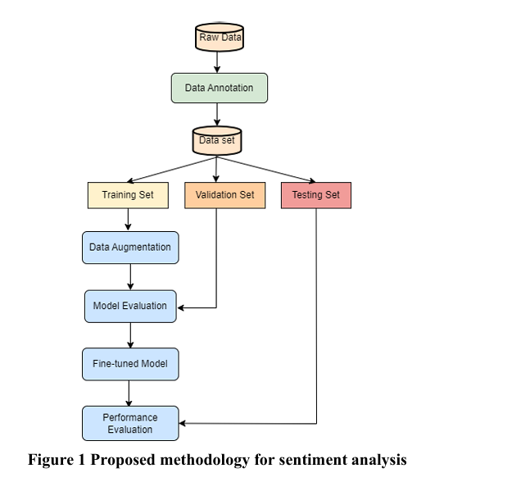

4. Evaluation Metrics
The performance of the model is evaluated using:
- Accuracy → Measures overall prediction correctness
- Sentiment Polarity Scores → Positive (+1), Neutral (0), Negative (-1)
- Pearson Correlation (r = 0.42)
  - Measures relationship between sentiment and ratings
- Linear Regression Coefficient (0.24)
  - Shows impact of sentiment on numerical scores
These metrics help assess both model performance and real-world applicability.

5. Results and Discussion
- Model achieved 90% testing accuracy
- Sentiment distribution after processing:
  - Positive: 147
  - Neutral: 152
  - Negative: 132
- Correlation Analysis
  - Moderate positive correlation (r = 0.42)
  - Positive sentiment generally leads to higher ratings
- Regression Analysis
  - Coefficient = 0.24
  - Sentiment has a positive but limited influence on ratings

6. Conclusion
The study demonstrates that sentiment analysis using NLP can significantly enhance the analysis of student feedback. The use of a transformer-based model like DistilRoBERTa provides high accuracy and reliable sentiment classification.
However, the results show that while sentiment is related to student ratings, it is not the only factor affecting course evaluations. Therefore, sentiment analysis should be used alongside other evaluation methods for better decision-making.

7. References
Badhan, S. J., Samsami, R., & Nossoni, G.
“Student Feedback Analysis Using Natural Language Processing (NLP) and Sentiment Analysis”,
American Society for Engineering Education, 2025.
.

